Agile Software Development

Assignment One

**Summary:**

From the start, I was sceptical if there was much difference between Scrum and XP; they are but subtle, but they can impact developers and production. I concluded that 'Scrum' would be in fact, the chosen framework from the Agile Methodology…

The core values carry a philosophy of harmony into a work environment, where it is often very intense: the five values, **commitment**, **courage**, **focus**, **openness** and **respect**. This brings production up as the teams feel more co-ownership of their contribution and design is at higher-end product. This is one reason why I would recommend ‘Scrum’ for its Core Values along with the teams’ structure no one team member is out of the loop.

Broadly speaking 'Scrum' pronominally focuses on management and productivity, done… (rather than how it is built), with little emphasis on the code, based more on observation and experimentation.

The failure aspect is when the project not adhering to the Scrum Core Principles, not following the framework could lead to project delays, overreaching budgets which will affect the CGHM (stakeholders) and in some cases avoidable.

Looking at **XP** practices that are more prescriptive and stricter as in the engineering, test-driven development, automated testing, pair programming, design(simple) refactoring and many more.

For the research part, I was able to access articles, eBooks, video interviews, blog post and many Scrum organisations. While I found there was so much information on Scrum Framework, what rings through and stands out for me, there is 'only one guide' whatever way you look at it… statistically speaking there is an enormous reignition for the 'Scrum Framework'.

*'90 % estimated Agile Teams use Scrum*

*+12M Estimated Using Scrum*

*One Scrum Guide'.*

Source: Scrum.org

**Introduction**

This paper aims to determine a somewhat better understanding of Agile Methodology for CGHM (company/customer) with a brief but comprehensive look at both 'Extreme Programming' (XP) and 'Scrum' frameworks.

According to many references, both 'XP' and 'Scrum' have some similarities and parallels in practice; they both focus on high-end quality and products produced as fast as possible. In essence, 'time is money' within the fast-changing market for features/products. The research will focus primarily on the **Scrum Framework**, as a proper consideration of time issues and a long comparative paper is beyond the scope of the given project.

**What is Scrum;**

Scrum.org states it is 'A better way of building products. It is a framework that is lightweight, simple to understand, but difficult to master'.

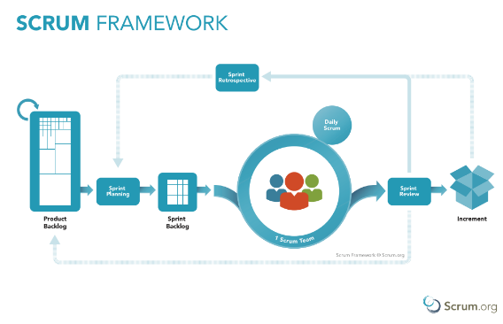

Resource: Scrum.org

**The company;**

CGHM (new company) has formed intending to produce an e-commerce website to rival Amazon. CGHM (customers, stakeholders) mainly built of corporate stakeholders with little to no experience with the building/development and details for implementing their new site (non-technical background). The customer CGHM is envisioning the product, with its 'Story,' with no specification in product management, roles, and responsibility, i.e., 'who goes where, and who will do what.'

Agile methodology for CGHM, as mentioned in the introduction, compares Agile Projects, i.e., priorities, development process (sprints), and CGHM's story' briefly outlining their desired functionality and the product/deliverable version for the end-user experience.

**The Development Team;**

The team of developers is an experienced unit of 8 individuals; although hired by CGHM, they are an independent team brought together for the intended purpose of developing an e-commerce site for CGHM. The developers are working on site but away from CGHM commercial practice.

In simple terms, the **Product Owner** (with the vision) is the go-between the Development Team and CGHM (Stakeholders), optimising the value of Developers' work. The Product owner represents CGHM and will hold CGHM product requirements, and the vision.

**Scrum Master**; is responsible for the Scrum framework, adopted and used correctly, support and guides the process. The Scrum Master will have a demanding role, from team dynamics, the developers, with Product Owner ensuring good relationships and even down to keeping the team on target eliminating distractions (a conducive environment).

**Developers**; One of the Scrum values in creating the development team, is bringing them together and then self-organising into the new structure.

The development team is a cross-functional as in they will know pretty much all aspects of the build, for example, a member of the team is required in a different role on a given day, i.e. testing, this should be no problem as there is a cross-functional team.

**Scrum Values:**

In the planning phase, the developers (tech team) will essentially and collectively **focus** on Sprint and goals of the Scrum Team looking at this project's scope and practices. The Scrum team are **committed** to achieving the goals and **courage** from team members to be heard. **Respecting** each other and capabilities and self-organisation within the team of developers. The Scrum team and CGHM (stakeholders) will have to agree to **openness** around production, and its challenges, this, in turn, will show no ambiguity just **transparency**.

**The story:**

The 'story' is the fundamental artifact; this defines CGHM desired product behaviour. Starting with the CGHM story and building it in a single functional form and possibly an incremental useable condition.

It is implemented incrementally; the developers can provide CGHM with validation or even a solution to a feature or adding a new feature.

It essential to note that the Scrum framework will not allow changes in their timeline or guidelines, for example, during a sprint. It sounds un-amendable, but the commitment to the set of backlog items are in production and remain untouched until that Sprint ends.

It can be accommodated, during the **adaptation** process, for example, daily stand-up meetings, retrospect sprint meeting, it can only happen when there is **transparency** from the stakeholders, and the core Scrum teams as the **inspection** occurs the adaption/improvements and the product backlog is adjusted. This is called the **Empirical** process will allow the team to build a part of the product and validate with the CGHM (stakeholders) needs.

The **Sprint** (interactions) are at two to four weeks of a calendar month. Potentially a shippable product increment, this depends on CGHM if they want to deploy that product.

**The daily Scrum** is usually 10 to 15 minutes standing meeting that allows the developers to inspect the progress of Sprint Goals and working on Sprint Backlog. Every day the development team will discuss in ways of how to accomplish the Sprint Goal.

The typical **Sprint Retrospective** model, what is working well, how can we improve, what will they prioritise for the next Sprint. This time will allow the Scrum team to have their comments (Q&A), that can make actionable comments.

When the Scrum Teams work together, their increments are integrated; this will allow the Product Owner to **inspect**, **review**, and **adapt** with the Stakeholders and collect feedback for future steps.

The **Sprint Backlog** is defined during the **Sprint Planning**, giving the development team time to the best forecast of what is, can do, from the start Sprint.

The development team will produce Product Backlog items and are inspected with the Product Owner. The Product Owner **prioritises** the backlog, but the scrum team will determine which they will develop from the backlog items, they will often choose high-priority items.

The new Sprint starts immediately at the end of the previous Sprint. If the product owner needs work estimates in Scrum, the Scrum Master would be guided by the development team.

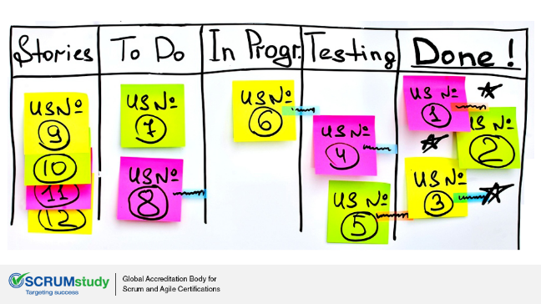

*Resource: SCRUMstudy.com*

**Conclusion:**

What is essential for the Scrum to integrate its framework in the CGHM development plan? A team, experience, a conducive environment, a good communication structure and openness.

Why following the Core Values? the core values carry a philosophy of harmony into a work environment, where it is often very intense: the five values, **commitment**, **courage**, **focus**, **openness** and **respect**. This brings production up as the teams feel more co-ownership of their contribution and design is at higher-end product.

Can they integrate other features as in add-ons to the Scrum framework to suit production and CGHM? The answer yes, some teams will maintain the Scrum core but may add other practices from the Agile practises for their product development.

***References***

Beck, K. (2001, March 23). Interview with Kent Beck and Martin Fowler. Retrieved from InformIT.

Borisenko, K. (n.d.). Difference Between Extreme Programming vs Scrum. Retrieved from Jelvix: https://jelvix.com/blog/scrum-extreme-programming-difference

Dictionary, O. (n.d.). Oxford Dictionary.

Scrum Framework poster. (n.d.). Retrieved from Scrum.org: https://www.scrum.org/resources/scrum-framework-poster

Wake, B. (2002, February 26). XP on One Page. Retrieved from XP123.